Project Design Phase
Solution Architecture

Date | 08/10/2026
Team ID | 9100Orbit
Project Name | Implement Client Script and UI Policy
Maximum Marks | 4 Marks

Solution Architecture:
Solution architecture is a complex process – with many sub-processes – that bridges the gap between business problems and technology solutions. Its goals are to:
- Find the best tech solution to solve existing business problems.
- Describe the structure, characteristics, behavior, and other aspects of the software to project stakeholders.
- Define features, development phases, and solution requirements.
- Provide specifications according to which the solution is defined, managed, and delivered.

Solution Architecture Diagram:

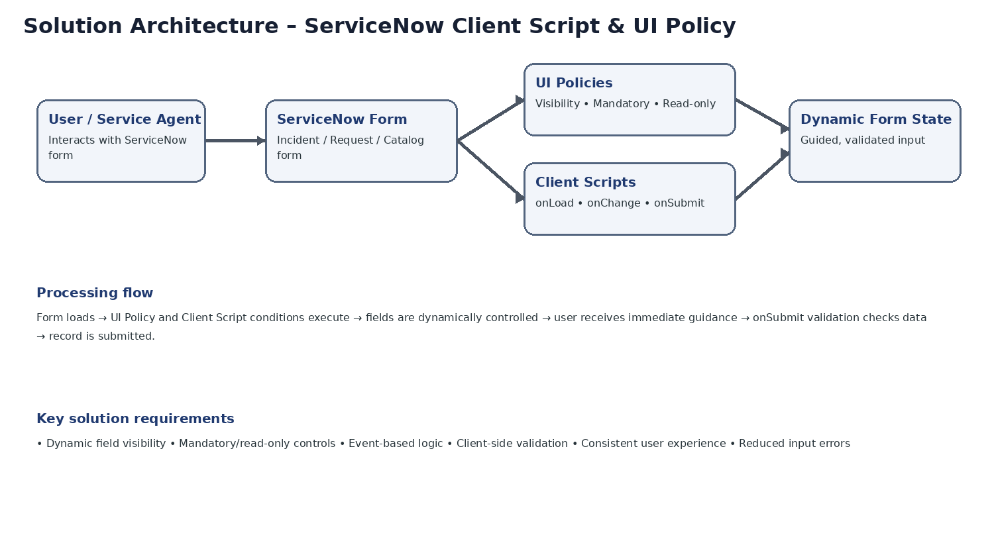
Figure 1: Architecture and data flow of the ServiceNow Client Script and UI Policy solution
Reference: Project-specific architecture prepared from the submitted template and project requirements.

For this project, the architecture connects the ServiceNow user and form with UI Policies and Client Scripts. UI Policies control field visibility, mandatory status and read-only status, while Client Scripts handle onLoad, onChange and onSubmit behaviour and validation.

